MODULE-3
1.) Created TblBookings and TblRates by doing merge query in the Power Query Editor.
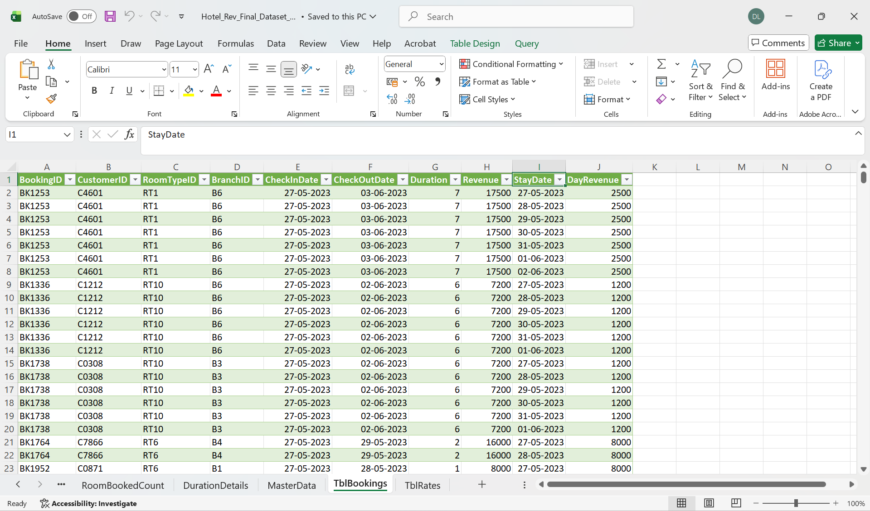
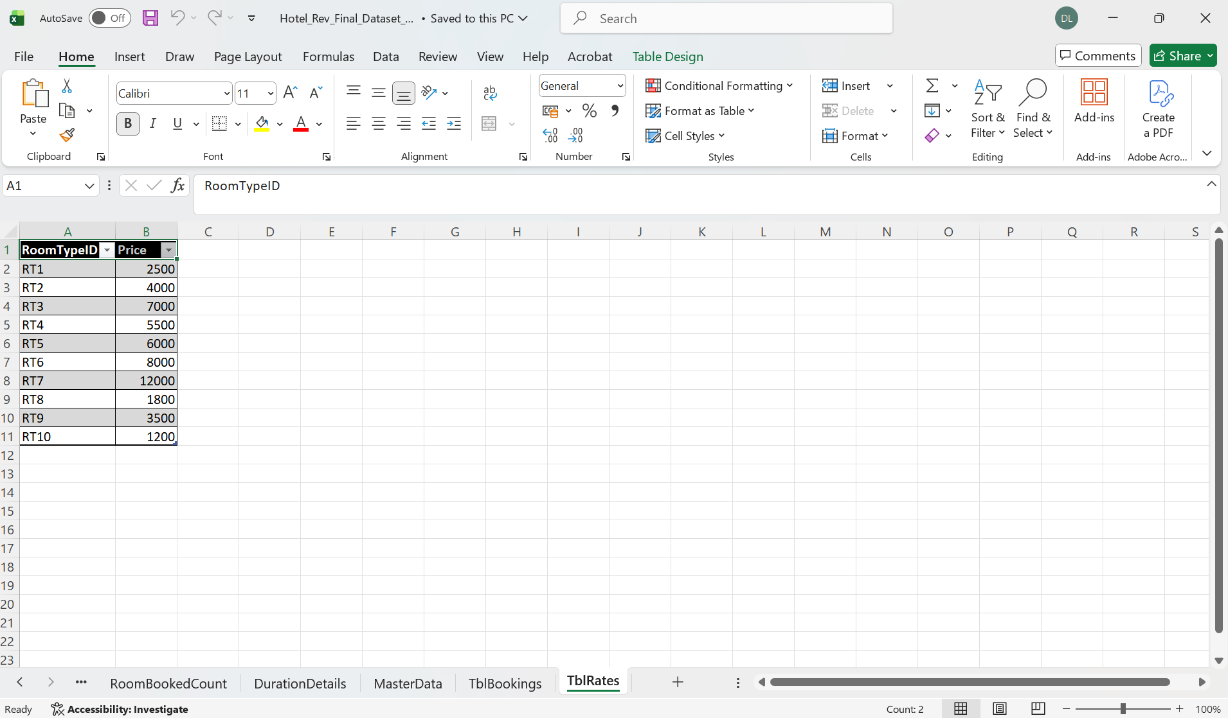

-------------------------------------------------------------------------------------------------------------------------
2.) Added Nationality column in Customer table.
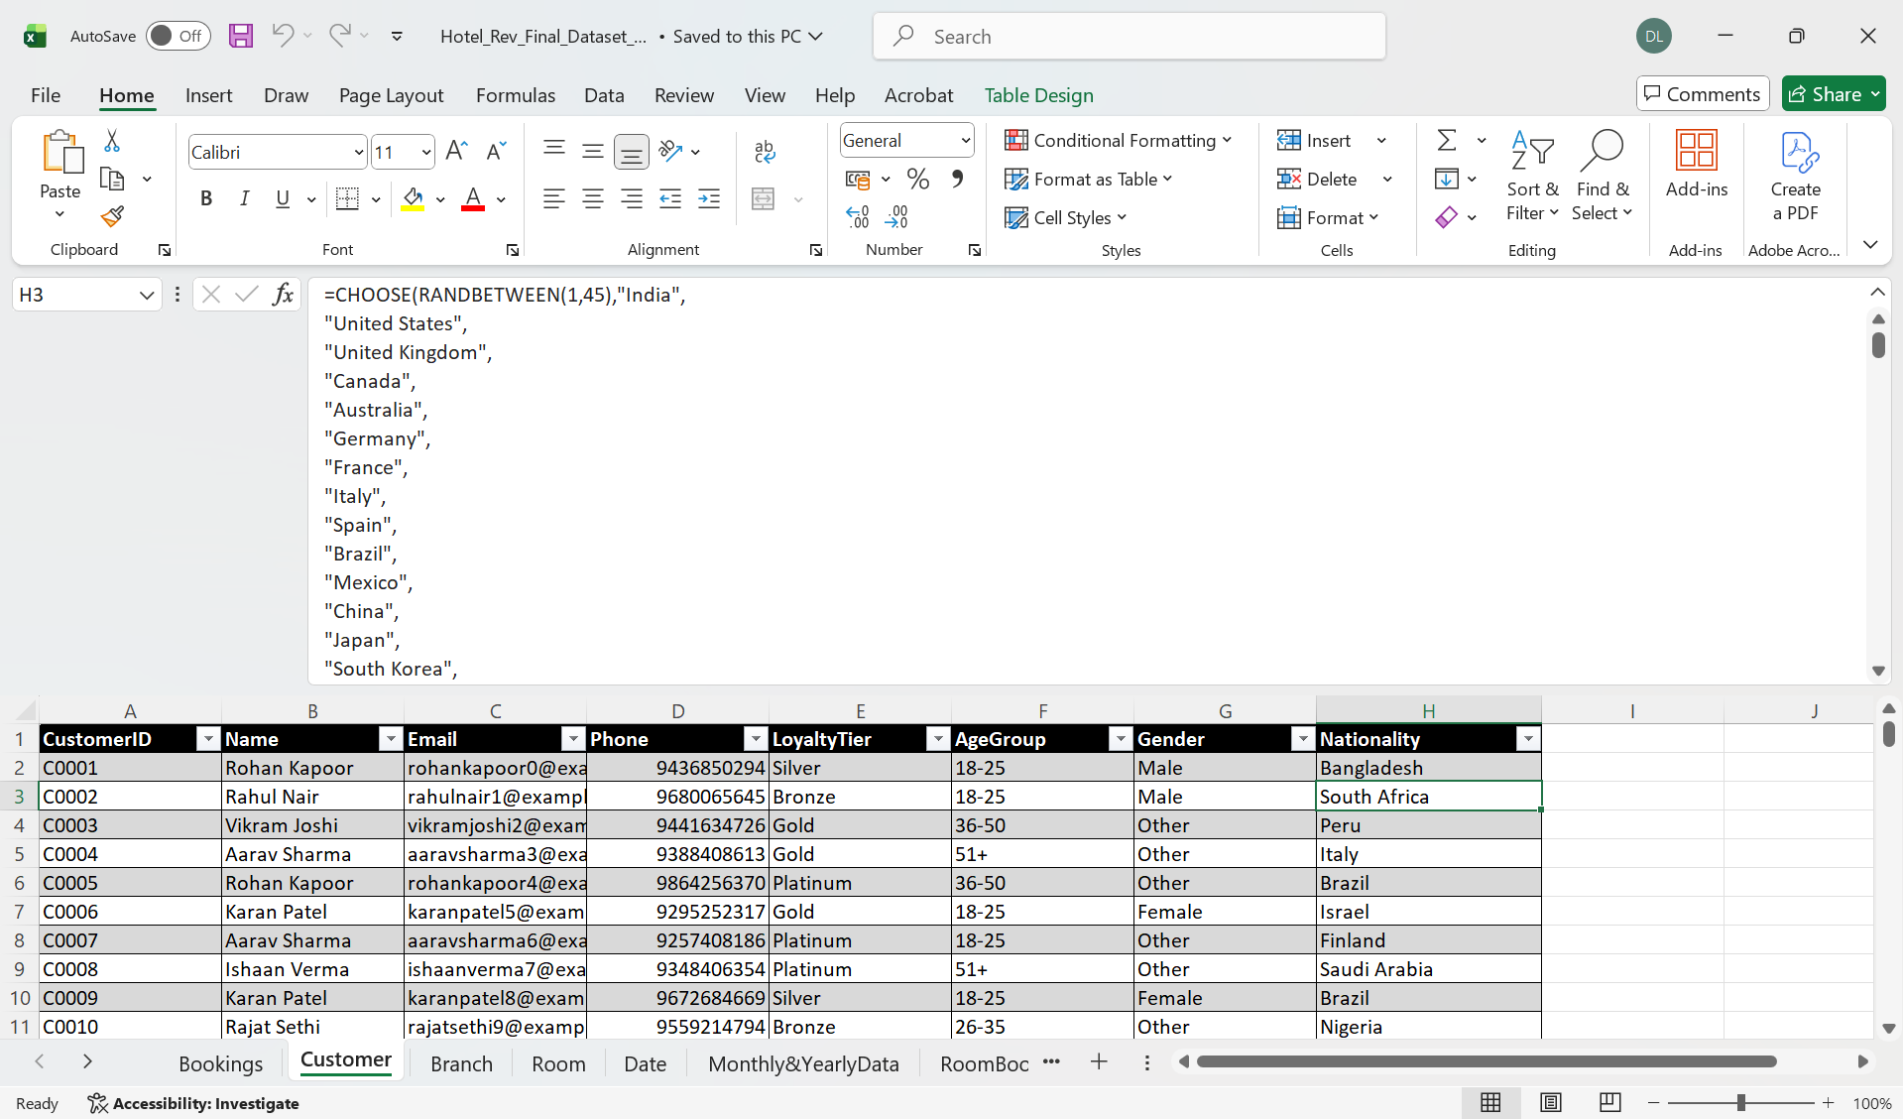

--------------------------------------------------------------------------------------------------------------------------

3.) In Power BI, refresh and load the remaining data in it and then we have added SourceType, GuestType, RoomRate, NumOfBookings, CustomerCluster columns in bookings table.
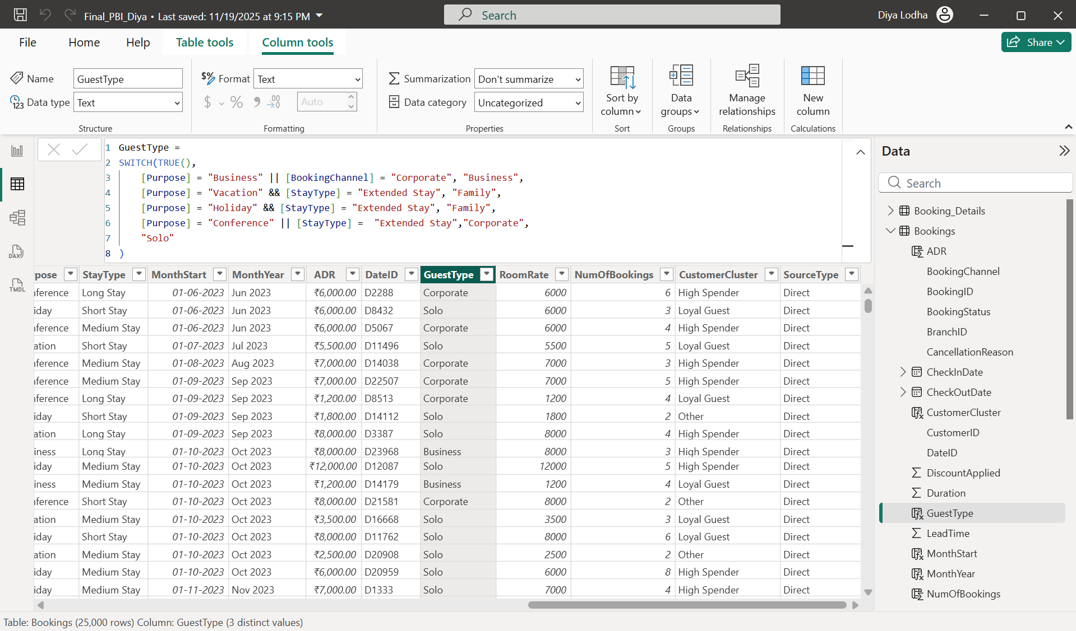
SourceType =
SWITCH(
'Bookings'[BookingChannel],
"Call Center", "Direct",
"Mobile App", "Direct",
"Website", "Direct",
"Travel Agent", "OTA",
"Other"
)
GuestType =
SWITCH(TRUE(),
[Purpose] = "Business" || [BookingChannel] = "Corporate", "Business",
[Purpose] = "Vacation" && [StayType] = "Extended Stay", "Family",
[Purpose] = "Holiday" && [StayType] = "Extended Stay", "Family",
[Purpose] = "Conference" || [StayType] = "Extended Stay","Corporate",
"Solo"
)
RoomRate = RELATED(Room[Price])
NumOfBookings =
CALCULATE(
COUNT(Bookings[BookingID]),
ALLEXCEPT(Bookings, Bookings[CustomerID])
)
CustomerCluster =
SWITCH(TRUE(),
[NumOfBookings] = 1 && [Revenue] < 5000, "First-Timer",
[NumOfBookings] >= 3 && [Revenue] < 15000, "Loyal Guest",
[Revenue] >= 15000, "High Spender",
"Other"
)

-------------------------------------------------------------------------------------------------------------------------
4.) Then we have created a table named as TblGuests in Power BI and added columns named as FrequencyScore, SpendScore, RecencyScore.

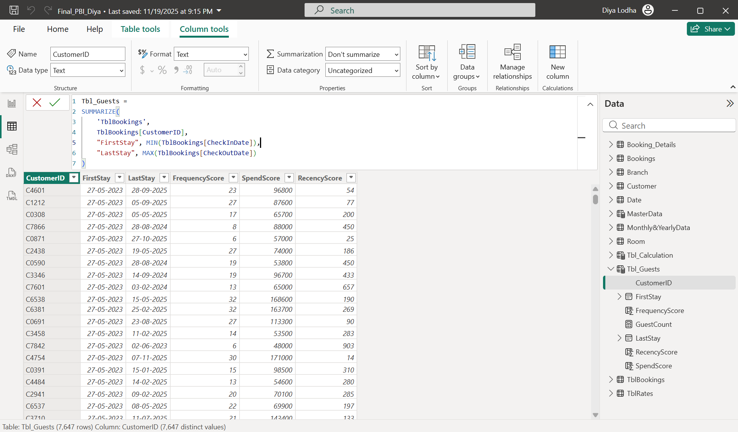
--------------------------------------------------------------------------------------------------------------------------
VISUALISATION

Guest Analysis:
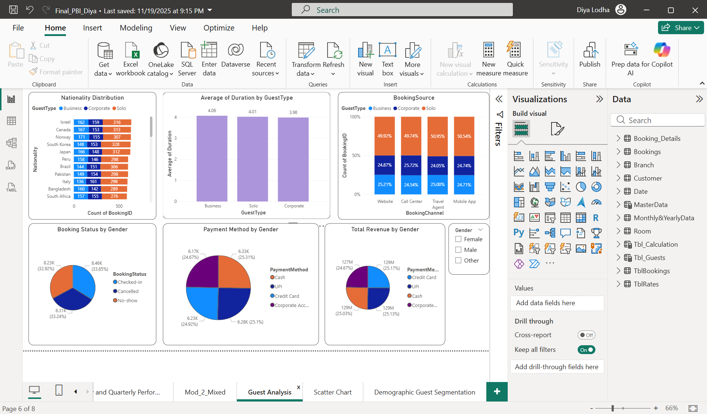
--------------------------------------------------------------------------------------------------------------------------
Scatter Chart (Based on sum of SpendScore, sum of FrequencyScore and CustomerID by RecencyScore and CustomerCluster):
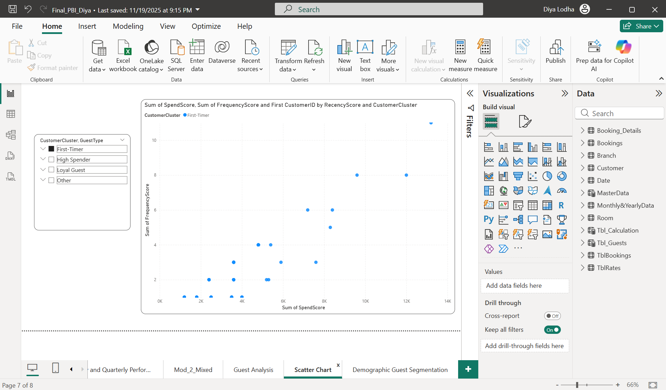
--------------------------------------------------------------------------------------------------------------------------
Demographic Guest Segmentation (Based on Nationality , CustomerCluster, SourceType, GuestType):
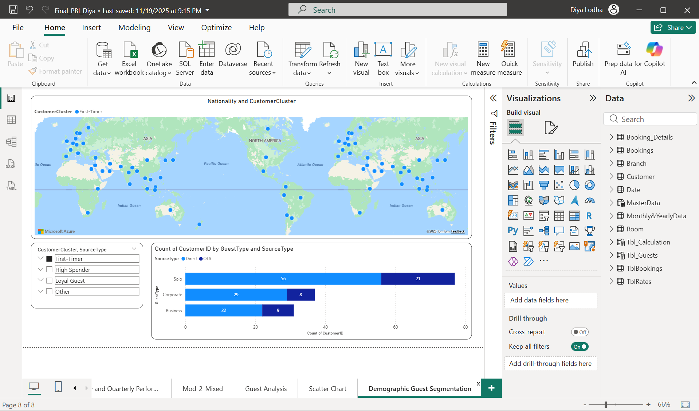

DASHBOARDS
Module 1 Dashboard: Overview
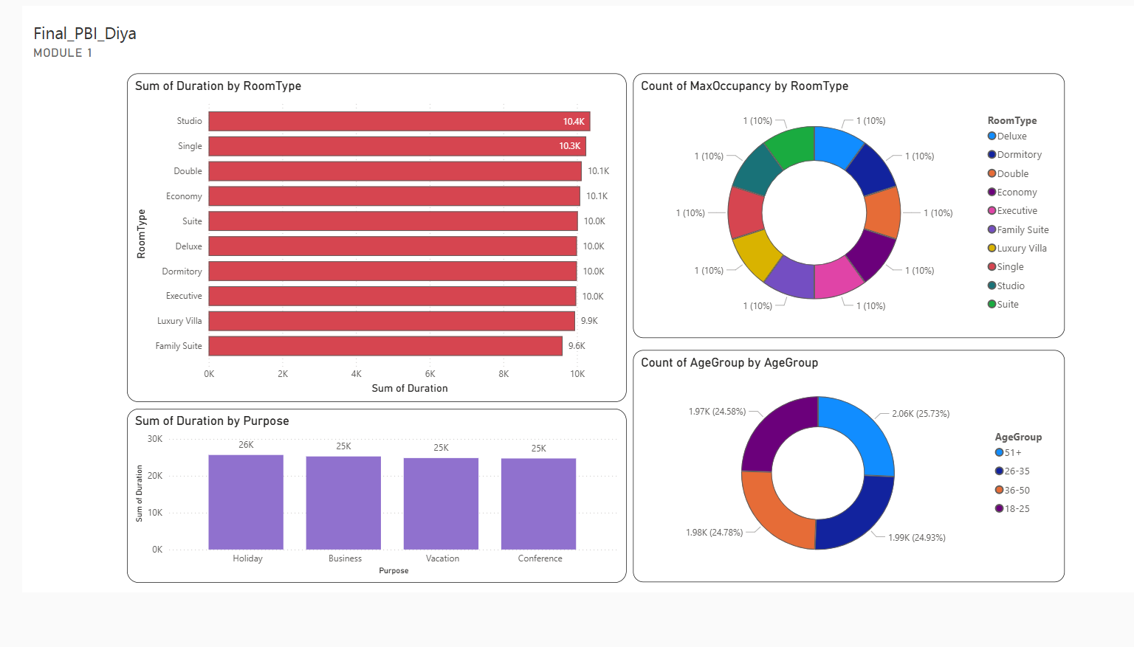Module 2 Dashboard: Trends with respect to ADR, Occupancy% and RevPAR
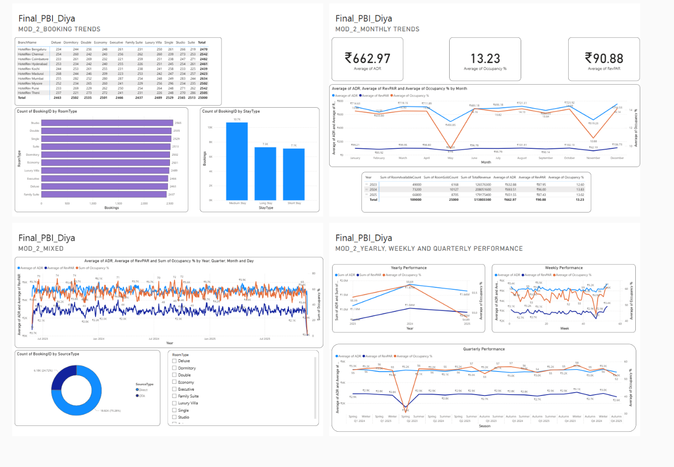
Module 3 Dashboard : Guest Analysis
